Port Blair on South Andaman Island is the capital city of the Andaman and Nicobar Islands, an Indian territory in the Bay of Bengal. Its seafront Cellular Jail, completed in 1906, hints at its past as a British penal colony and is now a memorial to Indian independence activists. Inland, the Samudrika Marine Museum showcases local marine life. The Anthropological Museum focuses on the islands’ indigenous tribes.

Havelock Island is part of Ritchie’s Archipelago, in India’s Andaman Islands. It’s known for its dive sites and beaches, like Elephant Beach, with its coral reefs. Crescent-shaped Radhanagar Beach is a popular spot for watching the sunset. On the island’s east side, rocky sections mark long, tree-lined Vijaynagar Beach. The island's forested interior is home to birdlife such as white-headed mynas and woodpeckers.

[3-day trips from ₹ 42,756](https://www.google.co.in/destination/plantrip?q=andaman&safe=strict&sa=X&dcr=0&biw=1137&bih=681&site=search&output=search&dest_mid=/m/059kwj&tpd=2018-04-24,2018-04-28)[11h 45m flight to Port Blair, from ₹ 23,763](https://www.google.co.in/flights?safe=strict&dcr=0&biw=1137&bih=681&site=search&output=search&dest_mid=/m/059kwj&sa=X&ved=0ahUKEwiejpmS7KnaAhWMLo8KHcF8CggQ69EBCCkoATAA&tfs=CAoQAho8EgoyMDE4LTA0LTI0agcIARIDQkJJag0IAxIJL20vMDNjenFzcgcIARIDSVhacg0IAxIJL20vMDU5a3dqGjwSCjIwMTgtMDQtMjhqBwgBEgNJWFpqDQgDEgkvbS8wNTlrd2pyBwgBEgNCQklyDQgDEgkvbS8wM2N6cXM)[3-star hotels average ₹ 6,331](https://search.google.com/local/places/hotel/categorical?q=hotels+in+havelock+island&hotel_dates=2018-04-24,2018-04-28&hotel_ds=1&immersed=1&sa=X&ved=0ahUKEwjm8aq-7KnaAhUPTo8KHWtuD2UQumgIEQ)

The Nicobar Islands are an archipelagic island chain in the eastern Indian Ocean. They are located in Southeast Asia, 150 km north of Aceh on Sumatra, and separated from Thailand to the east by the Andaman Sea. Located 1,300 km southeast of the Indian subcontinent, across the Bay of Bengal, they form part of the Union Territory of Andaman and Nicobar Islands, India. UNESCO has declared the Great Nicobar…

Cellular Jail

4.6

(3,060)

Former colonial prison, now a memorial

Ex–solitary confinement jail dating to British colonial times, now a national independence memorial.

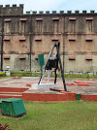

Samudrika Naval Marine Museum

4.3

(466)

Marine-life museum with a gift shop

Museum showcasing marine life & island history with coral, fish, shells & many items for sale.

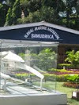

Forest Museum

4.2

(98)

Sawmill with historical exhibits & art

Large sawmill with an educational museum on the forestry industry, plus wooden artwork for sale.

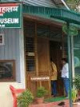

Kalapani Museum

4.1

(43)

Exhibits exploring local history

Exhibits exploring the history of the Andaman & Nicobar islands through photos, paintings & models.

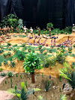

Ross Island, South Andaman district

Ross Island is an island of the Andaman Islands. It belongs to the South Andaman administrative district, Andaman and Nicobar Islands. The island is situated 3 km east from downtown Port Blair

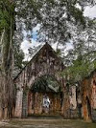

Viper Island

Harbor

Viper Island is an island of the Andaman Islands. It belongs to the South Andaman district of the Andaman and Nicobar Islands. The island lies 4 km west of Port Blair.

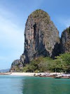

Rajiv Gandhi Water Sports Complex

4.3

(601)

Scenic place with jet skis & speed boats

Popular, scenic locale with a jetty offering jet skiing, speed boating & other water activities.

Mount Harriet National Park

4.4

(121)

Forested park with wildlife & views

Photography is popular at this serene, forested national park with wildlife viewing & butterflies.

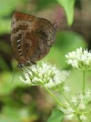

Mahatma Gandhi Marine National Park

4.5

(161)

Protected islands with coral reefs

National preserve made up of 2 islands with coral reefs & sea turtles, plus a marine life center.

Chidiya Tapu

4.3

(349)

Small beach known for scenic sunsets

Compact beach popular for birdwatching & sunset viewing, with a nearby mini-zoo.

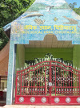

Marina Park

4.3

(667)

Scenic waterfront park with playgrounds

Small park with scenic views, kids' play areas & a long pier with access to boating & water sports.

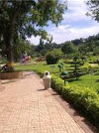

Corbyn's Cove Beach

4.1

(1,059)

Beach with jet-skiing & snack bars

Sandy, palm-fringed beach with jet-ski rentals, lounge chairs & several casual eateries.

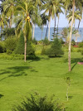

Gandhi Park

4.0

(243)

Roomy park with a lake & playgrounds

Large, serene park with gardens, walking paths, a lake & multiple kids' play areas.

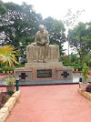

1. Mini Zoo

3.4

(182)

Simple zoo with animals & greenery

Modest zoo featuring animals such as fish, ostriches & monkeys in a lush setting.

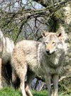

1. Munda Pahar Beach

4.3

(364)

Calm beach for swimming & sunset views

Secluded, picturesque beach offering sunset views & a protected area for swimming.

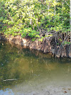

1. cellular jail - museum

4.7

(35)

Museum

